Workshop on the
R Statistical Package

Instructor: David Lieske, Ph.D. Candidate
Time: 12:00pm to 4:30pm
Date: Wednesday, Sept. 27
Format: In the computer lab

Workshop Overview

Day 1

- Give a brief overview of the R Statistical Package: its strengths, weaknesses, and the type of problems it’s ideal for.
- Introduce you to the software and its language (or: “why it’s so powerful”).
- Discuss data queries, importation, manipulation, and inspection.
- Explore R’s powerful graphical tools, using distributional data for the American Crow (AMCR).

Day 2

- Dive into the details of modeling in R – how to specify models, how to retrieve output from models.
- Discuss aspects of model fit using the ANOVA and logistic regression as examples.
- Discuss aspects of model selection.
- Build a base distribution model for the AMCR.
- Build a GWR distribution model for the AMCR.

Worksheet #1

PART 1

- R is really a language. In this sense it’s much more than a software program because once you’ve mastered the basic nuts & bolts you can solve any problem that comes your way – the best way to get a feel for it is to just try it out!

- Where can you get it? Visit the following site:
http://www.r-project.org

- Some of R’s strongest features are:

  - A very compact and flexible language – that means you can do more with less lines of code (really, there isn’t a problem that can’t be tackled…).
  - The R language is object-oriented -- everything that is created in R, whether a variable or a matrix or what-have-you, is retrievable by name and has properties (e.g., labels).
  - Object-oriented design also applies to the output from R – you can grab anything you need and recombine it.
  - R is ideal for simulation and modeling work, because you can re-run tasks many times and dynamically interact with the results at each iteration.
  - R has beautiful graphical output.
  - R has a progressive and generous user community who are always more than ready to offer advice – many, many state-of-the-art packages are available.
  - Free of charge!

- The language is very compact and elegant, but not necessarily easy to learn or read. Different programmers have different styles, for example, the way that they name the various objects in R. You’ll naturally develop your own style so don’t worry too much about it. However, try to be consistent and systematic.

- Back to the object-oriented aspect of R…

In addition to simple objects like arrays, R also uses functions, which are also objects – but ones that can execute code. Non-function objects cannot execute commands for you.

Fundamentals: Objects and Assignment

- The Assignment Operator

** The simplest possible example of the use of the assignment operator “<-“ involves a scalar (single value) assigned to an object (e.g., “x”):

x <- 5

The following command line creates a vector object called “x” and assigns to it the set of numbers combined together by the “c()” function.

x <- c(1,2,3,4,5,6,7,8,9,10)

It’s no problem to retrieve the values of object “x” – just type it’s name!

> x
[1] 1 2 3 4 5 6 7 8 9 10

It’s quite easy to generate a simple scatterplot of the values of object “x” – just use the “plot()” function:

> plot(x)

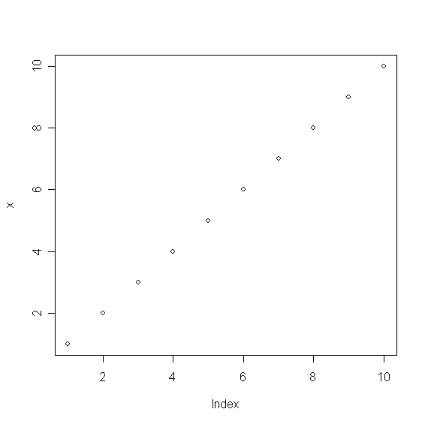

Here’s another function I’d like to give you the heads-up about, because it’s really helpful for querying information about more complicated objects like lists or dataframes – it’s the “str()” function:

> str(x)
num [1:10] 1 2 3 4 5 6 7 8 9 10

Object Queries

- Ok, what if you want to plot only the last 5 values in your vector object “x”? How would you go about querying subsets of the data?

> x[5:10]
[1] 5 6 7 8 9 10

- Now if you want to plot just this subset you can by passing it to the plot() function:

plot(x[5:10])

- Some other simple queries…

> x[x>8]
[1] 9 10

> x[x>8 | x<2]
[1] 1 9 10

> x[x>8 & x<2]
numeric(0)

> x[-5]
[1] 1 2 3 4 6 7 8 9 10

- We’ve now discussed two types of queries –

(1) queries based on position in the vector (e.g., the 5th value, x[5]);
(2) queries based on the values in the vector (e.g., all values in the “x” object greater than eight, x[x>8]).

- Ok, let’s pretend that object “x” was really a variable like crime rate – let’s create a variable for this called “crime”, and while we’re at it, let’s also create a predictor (independent) variable called “propval” (to represent property value):

> crime <- c(13.1,4.5,11.0,18.9)
> crime
[1] 13.1 4.5 11.0 18.9

> propval <- c(125,87,133,84)
> propval
[1] 125 87 133 84

> plot(propval,crime)

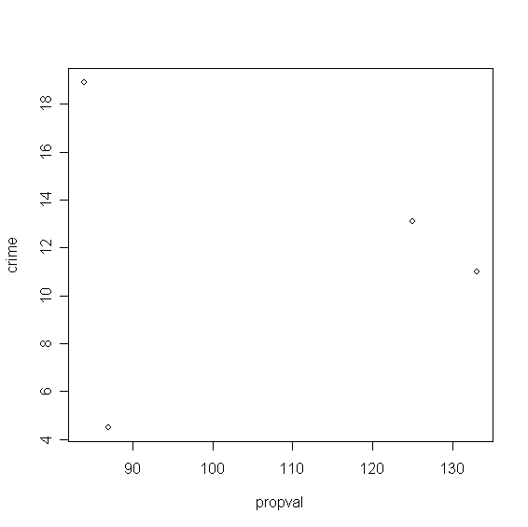
- How did I know that I could produce a two-way scatter plot (propval vs. crime)? This would be a good time to mention R’s help menu…

> ?plot

plot package:graphics R Documentation

Generic X-Y Plotting

Description:

Generic function for plotting of R objects. For more details
about the graphical parameter arguments, see 'par'.

Usage:

plot(x, y, ...)

Arguments:

x: the coordinates of points in the plot. Alternatively, a
single plotting structure, function or _any R object with a
'plot' method_ can be provided.

y: the y coordinates of points in the plot, _optional_ if 'x' is
an appropriate structure.

...: graphical parameters can be given as arguments to 'plot'.
Many methods will also accept the following arguments:

'type' what type of plot should be drawn. Possible types are

* '"p"' for *p*oints,

* '"l"' for *l*ines,

* '"b"' for *b*oth,

* '"c"' for the lines part alone of '"b"',

* '"o"' for both "*o*verplotted",

* '"h"' for "*h*istogram" like (or "high-density")
vertical lines,

* '"s"' for stair *s*teps,

* '"S"' for other *s*teps, see _Details_ below,

* '"n"' for no plotting.

All other 'type's give a warning or an error; using, e.g.,
'type = "punkte"' being equivalent to 'type = "p"' for S
compatibility.

'main' an overall title for the plot: see 'title'.

'sub' a sub title for the plot: see 'title'.

'xlab' a title for the x axis: see 'title'.

'ylab' a title for the y axis: see 'title'.

Details:

For simple scatter plots, 'plot.default' will be used. However,
there are 'plot' methods for many R objects, including
'function's, 'data.frame's, 'density' objects, etc. Use
'methods(plot)' and the documentation for these.

The two step types differ in their x-y preference: Going from
(x1,y1) to (x2,y2) with x1 < x2, 'type = "s"' moves first
horizontal, then vertical, whereas 'type = "S"' moves the other
way around.

See Also:

'plot.default', 'plot.formula' and other methods; 'points',
'lines', 'par'.

Examples:

plot(cars)
lines(lowess(cars))

plot(sin, -pi, 2*pi)

## Discrete Distribution Plot:
plot(table(rpois(100,5)), type = "h", col = "red", lwd=10,
main="rpois(100,lambda=5)")

## Simple quantiles/ECDF, see ecdf() {library(stats)} for a better one:
plot(x <- sort(rnorm(47)), type = "s", main = "plot(x, type = \"s\")")
points(x, cex = .5, col = "dark red")

- Ok, after a while you end up with a lot of objects floating around. How do you list them?

> objects()
[1] "crime" "propval" "x"

- Great, let’s say I’m done for the day. How do I quit R and shut it down gracefully?

> q()

- You keeners in the audience may be worrying about how many commands you’re likely to type in a given R session – this is a valid concern! In addition to not wanting to have to re-type everything, you may want to review or audit the analysis later on, and for this you need a way to document what you’ve done.

I use Windows “notepad” to store all of my commands, and I name all of my files in this way:

script.R

The “.R” extension tells me it’s an R language scripting file, just like “.SPS” is an SPSS syntax file.

You can also retrieve all the commands you’ve typed in an R session using the “history()” function:

> history(max.show=5)
pairs(~df$DTR + df$PRECIP + df$TEMP)
history
history()
?history
history(max.show=2)
history(max.show=5)

PART 2

- The simplest way to import data into R is to use one of the standard ASCII data storage formats, namely comma or tab-delimited text files. There are at least three different functions you can use to import this type of data:

read.csv(file, header = TRUE, sep = ",", quote="\"",
dec=".",fill = TRUE, ...)

read.delim(file, header = TRUE, sep = "\t",
quote="\"", dec=".", fill = TRUE, ...)

read.table(file, header = FALSE, sep = "", quote =
"\"'", dec = ".", row.names, col.names, as.is =
FALSE, na.strings = "NA", colClasses = NA,
nrows = -1, skip = 0, check.names = TRUE,
fill = !blank.lines.skip, strip.white = FALSE,
blank.lines.skip = TRUE, comment.char = "#",
allowEscapes = FALSE)

- Let’s import the American Crow data. This data set contains occurrence data for 2799 survey points aggregated from 1997-2003 Breeding Bird Survey data for the boreal-hardwood transition zone.

- First have a look at the data in your favourite text editor to confirm how it’s been formatted:

xcoord ycoord presence …
1621035.14 4973929.11 1 …
1620893.71 4974728.34 1 …

- Now let’s use the read.table() function to import the data now that we know that it’s a tab-delimited text file:

> read.table("amcr.txt", sep="\t")

What did you see?

Let’s revise the previous command execution to assign the results of “read.table()” to an object called “df”:

> df <- read.table("amcr.txt", sep="\t", header=TRUE)

> str(df)

> str(df)
`data.frame': 2799 obs. of 13 variables:
$ xcoord : num 1621035 1620894 1620757 1620629 1616523 ...
$ ycoord : num 4973929 4974728 4975528 4976330 4976492 ...
$ CROPVEG : int 1 1 0 0 0 0 0 0 0 0 ...
$ CONIFER : int 0 0 0 0 0 0 0 0 0 0 ...
$ DECID : int 0 0 0 0 0 0 0 0 0 0 ...
$ MIXEDF : int 0 0 1 1 0 1 1 1 1 1 ...
$ EVIMEAN : num 5226 5226 4800 4270 5189 ...
$ EVISD : num 188 188 502 718 424 ...
$ ELEV : int 328 322 322 323 336 335 328 326 322 320 ...
$ DTR : num 11.1 11.1 11.1 11.1 11.1 ...
$ PRECIP : num 730 730 730 730 730 ...
$ TEMP : num 7.24 7.24 7.24 7.24 7.24 7.24 7.24 7.24 7.24 7.24 ...
$ presence: int 1 1 1 0 1 0 1 1 1 1 ...

- What are these variables? That’s where metadata comes in handy…

Table 1. Candidate variables used to model species distributions.
Variable Description Source
Land Cover
CONIFER Conifer-dominated forest MODIS 2001 land cover classification *
CROPVEG Cropland/natural vegetation mosaic MODIS 2001 land cover classification*
DECID Deciduous-dominated forest MODIS 2001 land cover classification *
MIXEDF Mixed (conifer-deciduous) forest MODIS 2001 land cover classification *
EVIMEAN Mean Enhanced Vegetation Index (EVI) for MODIS 16-day EVI **
a 3x3 neighbourhood
EVISD Mean Standard Deviation of the Enhanced MODIS 16-day EVI **
Vegetation Index (EVI) for a 3x3 neighbourhood
Climate
DTR Mean diurnal temperature range (⁰C) CRU_2_10 global climate data ***
PRECIP Total annual precipitation (mm) CRU_2_10 global climate data ***
TEMP Mean temperature (⁰C) CRU_2_10 global climate data ***

Topography
ELEV Elevation (m) GTOPO30 global digital elevation model****

*Derived from the MOD12Q1 (1-km resolution) layer incorporating the 17-class land cover classification system defined by the International Geosphere-Biosphere Programme (IGBP), U.S. Geological Survey (2006).
**Derived from the MOD13A2 (1-km resolution) layer for 25 June, 2004, U.S. Geological Survey & NASA (2006).
***Monthly averages (or annual totals, in the case of precipitation) were averaged over the years 1997-2002 at a resolution of 0.5⁰ x 0.5⁰ (Mitchell & Jones 2005).
****Global digital elevation data at an approximately 1-km resolution (U.S. Geological Survey 1996).

- Ok, what kind of object is “df”? It’s a data frame which is R’s standard format for representing data – Note that data frame objects are just like Excel spreadsheets. The have variables (with names), and data points are represented as rows in the table. You can manually edit data frames (if you need to, but R isn’t the best place to do this…):

> edit(df)

- Let’s explore the variables in this dataset, starting with the response variable:

presence

It’s a binary variable (1/0) indicating presence at anytime during the 1997-2003 period. Because it’s a categorical (dummy) variable with a small number of classes, it’s best summarized using a simple cross-tabulation:

> table(df$presence)

0 1
1581 1218

table() tabulated 1218 presence points (presence = 1) out of 2799 survey points (43.5% of locations).

We’ll explore further functions for summarizing and visualizing this data in Part 3.

PART 3

- What proportion of the survey points fall into the different land cover classes?

> table(df$CROPVEG)

0 1
2355 444

> table(df$CONIFER)

0 1
2600 199

> table(df$DECID)

0 1
2798 1

> table(df$MIXEDF)

0 1
1242 1557

Variable | % of Survey Points
CROPVEG | 444/2799 = 15.9%
CONIFER | 199/2799 = 7.1%
DECID | 1/2799 = 0.04%
MIXEDF | 1557/2799 = 55.6%

- What proportion of the AMCR presence points occur in the previous land cover types, and is their evidence of selection for or against each of the classes?

CROPVEG
> table(df$presence,df$CROPVEG);
chisq.test(df$presence,df$CROPVEG)

0 1
0 1415 166
1 940 278

Pearson's Chi-squared test with Yates' continuity correction

data: df$presence and df$CROPVEG
X-squared = 77.3781, df = 1, p-value < 2.2e-16

CONIFER
> table(df$presence,df$CONIFER); chisq.test(df$presence,df$CONIFER)

0 1
0 1431 150
1 1169 49

Pearson's Chi-squared test with Yates' continuity correction

data: df$presence and df$CONIFER
X-squared = 30.287, df = 1, p-value = 3.726e-08

DECID
> table(df$presence,df$DECID); chisq.test(df$presence,df$DECID)

0 1
0 1580 1
1 1218 0

Pearson's Chi-squared test with Yates' continuity correction

data: df$presence and df$DECID
X-squared = 0.0171, df = 1, p-value = 0.896

Warning message:
Chi-squared approximation may be incorrect in: chisq.test(df$presence, df$DECID)
>

MIXEDF
> table(df$presence,df$MIXEDF); chisq.test(df$presence,df$MIXEDF)

0 1
0 642 939
1 600 618

Pearson's Chi-squared test with Yates' continuity correction

data: df$presence and df$MIXEDF
X-squared = 20.5243, df = 1, p-value = 5.888e-06
>

Variable | % of Survey Points | % of AMCR Presence Points
CROPVEG | 444/2799 = 15.9% | 278/1218 = 22.8% (+)
CONIFER | 199/2799 = 7.1% | 49/1218 = 4.0% (-)
DECID | 1/2799 = 0.04% | 0/1218 = 0% (-)
MIXEDF | 1557/2799 = 55.6% | 600/1218 = 49.3% (-)

- What is the relationship between occurrence of AMCR and the continuous variables EVIMEAN, EVISD, DTR, PRECIP, TEMP, ELEV?

Let’s start with the EVIMEAN variable, but let’s look at its relationship with absence and presence separately:

> summary(df$EVIMEAN[df$presence == 0])
Min. 1st Qu. Median Mean 3rd Qu. Max.
1069 4495 5018 5078 5644 7343
> boxplot(df$EVIMEAN[df$presence == 0])
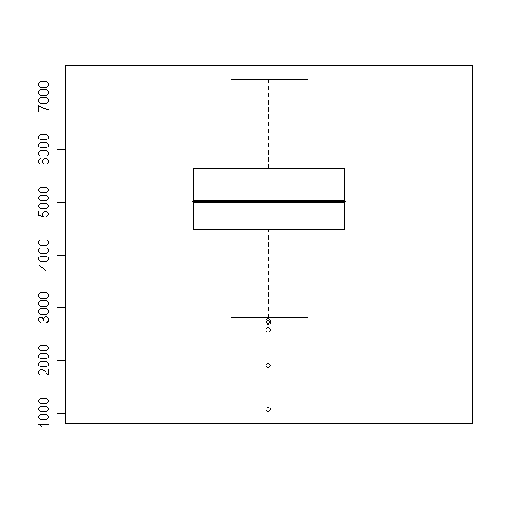

> summary(df$EVIMEAN[df$presence == 1])
Min. 1st Qu. Median Mean 3rd Qu. Max.
1069 5015 5558 5391 5989 7052
> boxplot(df$EVIMEAN[df$presence == 1])
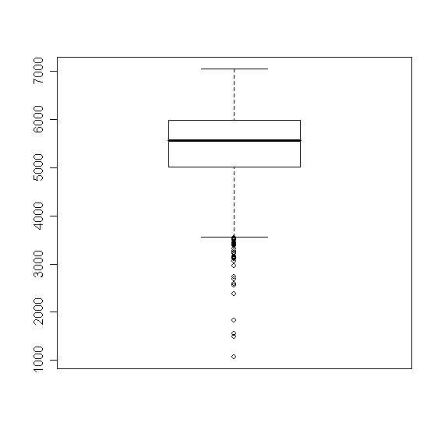
There is a way to change the default graphing parameters in R to customize the formatting of the output. In this case, I want to simultaneously view the previous output, for all six variables. I’ll use a 3x2 panel to achieve this:

> par.old <- par()
> par(mfrow=c(3,2))
> label <- c(“Absence”, “Presence”)
> boxplot(df$EVIMEAN[df$presence==0], df$EVIMEAN[df$presence == 1],main=”EVIMEAN”)
> axis(side=1, at=c(1,2), labels=label, lwd=1, font=1)

… [just copy and paste the following block of commands]

boxplot(df$EVISD[df$presence==0], df$EVISD[df$presence == 1],main=”EVISD”)
axis(side=1, at=c(1,2), labels=label, lwd=1, font=1)
boxplot(df$DTR[df$presence==0], df$DTR[df$presence == 1],main=”DTR”)
axis(side=1, at=c(1,2), labels=label, lwd=1, font=1)

boxplot(df$PRECIP[df$presence==0], df$PRECIP[df$presence == 1],main=”PRECIP”)
axis(side=1, at=c(1,2), labels=label, lwd=1, font=1)

boxplot(df$TEMP[df$presence==0], df$TEMP[df$presence == 1],main=”TEMP”)
axis(side=1, at=c(1,2), labels=label, lwd=1, font=1)

boxplot(df$ELEV[df$presence==0], df$ELEV[df$presence == 1],main=”ELEV”)
axis(side=1, at=c(1,2), labels=label, lwd=1, font=1)

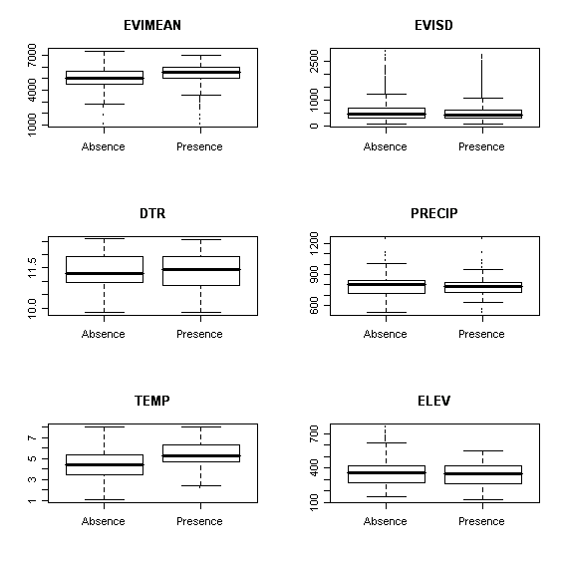

- Now that we’ve finished producing our 3x2 panel, you can reset the original graphing parameters this way:

> par(par.old)

- Another useful graphical exploratory data analysis (EDA) tool is the pairwise plot applied to continuous variables:

> pairs(~df$DTR + df$PRECIP + df$TEMP)

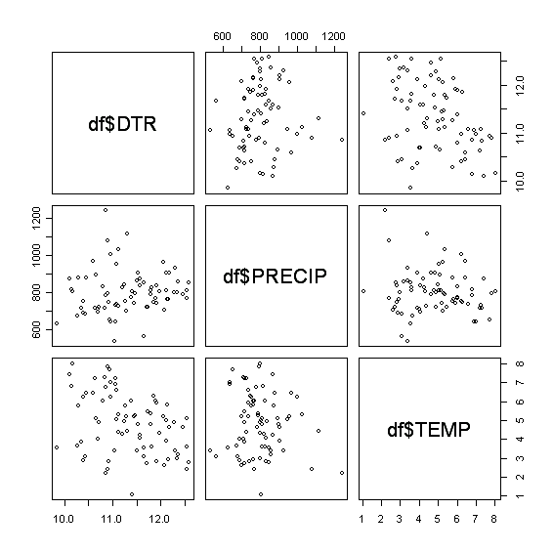

APPENDIX: Some notes for further exploration

- Exporting graphical output from R is pretty easy – if you right click on the image you can choose to either copy it, or save it. If you intend to copy and paste the image as I did in this worksheet, use the “copy to bitmap” option – it produces quite nice imbedded graphics. Another option is to save the image as a “encapsulated postscript”, which you can open into, for example, Adobe Illustrator. You can resize particular elements to your hearts content, as well as modify bits of the image. You could then export the finished product back to a bitmap, or some other format (GIFF, JPEG, etc.).

- You can export data from dataframes in a fashion analogous to importing data, using the “write.table()” function. For example, let’s say I have a dataframe called “data” that I want to export to a comma-delimited file called “export.txt” (with the first row containing the variable names):

> write.table(data, file=”export.txt”, sep=”,”, col.names=TRUE)

